Agenda for:

Summary of Findings: A Tree Preservation Study for Dover, MA
Saturday, March 11th, 2023

Zoom Link: https://us06web.zoom.us/j/84138469895
Time: 10:30 AM – 12:00 PM

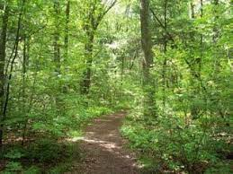

10:30 am Welcome & Introduction – Val Lin, Chair, Dover Tree Preservation Committee
- Introduction of the Tree Preservation Committee
- Introduction of The Conway School – Audrey Logan , Brett Towle, Kaitlynn Campbell

10:40 am Presentation
- Summary of findings about tree preservation in the Dover community
- Summary of tree preservation strategies (plans, policies, and programs) in surrounding towns and beyond MA
- Recommendations for next steps toward continued tree preservation efforts in Dover

11:20 am Small group breakout sessions
- Community members have an opportunity to ask questions and provide feedback in small groups with a member of The Conway School

11:45 am Wrap Up & Thank you

