81 & 85 Tisdale St, Dover.
Comprehensive Permit Application
Town of Dover - Zoning Board of Appeals.

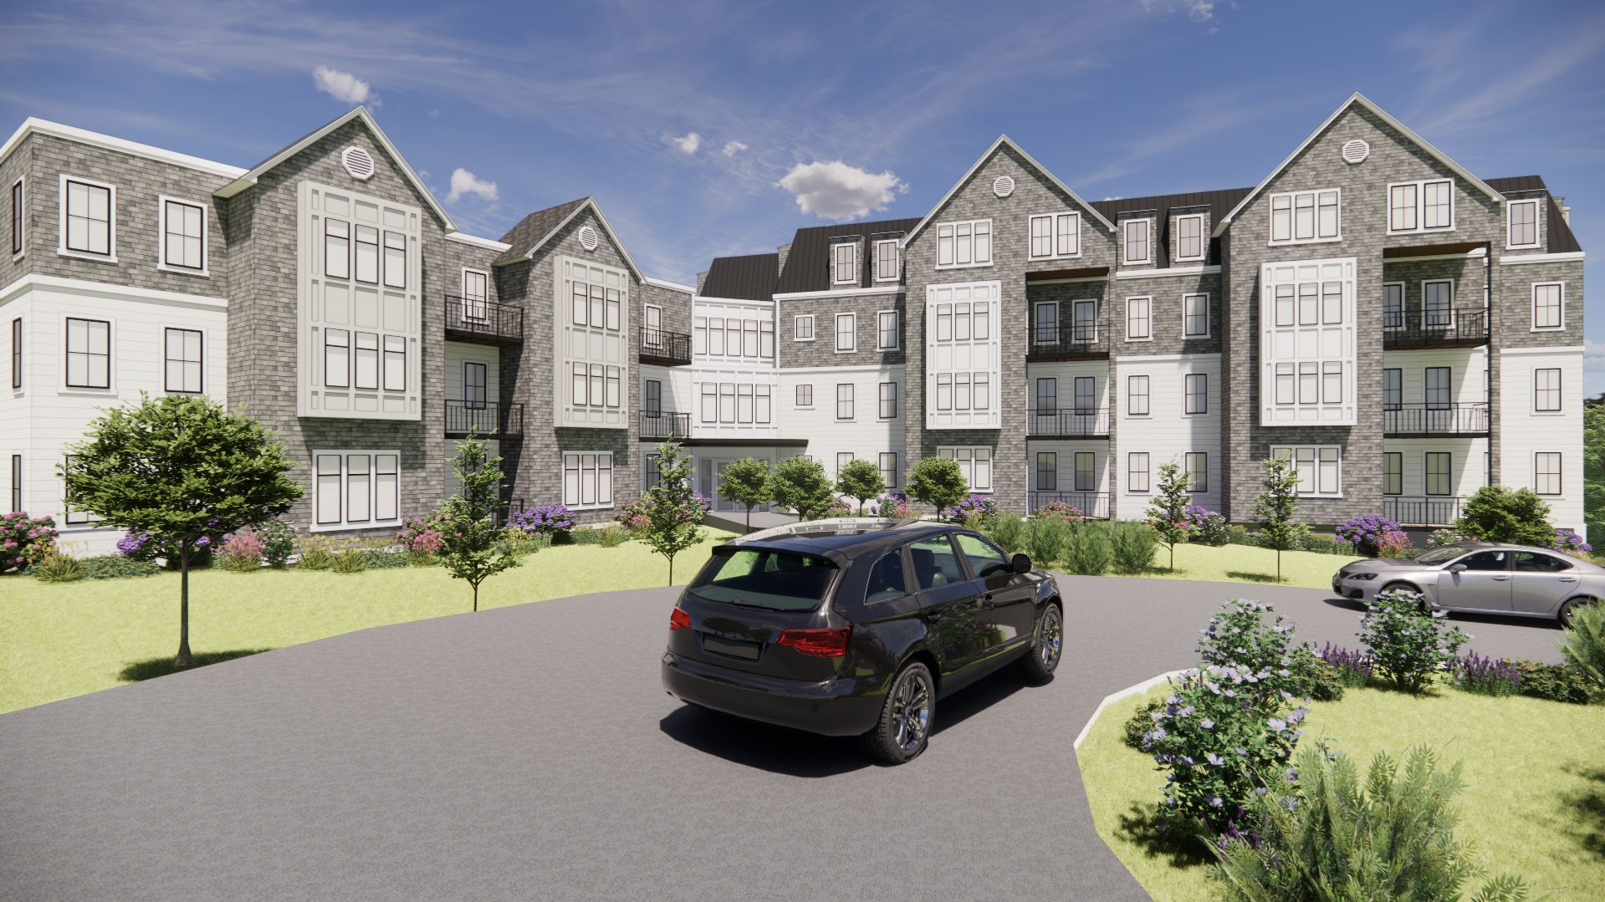

October 3rd, 2024

October 3rd, 2024.

Dover Zoning Board of Appeals,
P.O. Box 250,
Dover, MA 02030.

RE: Comprehensive Permit Application.
81 & 85 Tisdale St, Dover.

Dear Board Members,

We are pleased to submit the attached Application for Comprehensive Permit on behalf of Tisdale Drive Apartments for a proposed 42-unit apartment building at 81 & 85 Tisdale St, Dover. The proposed project has received a written determination of Project Eligibility/Site Approval from Mass Housing pursuant to Massachusetts General Laws, Chapter 40B. (Mass Housing ID No. 1200).

The project proposes to include 11 affordable rental units in the building. This application includes the following documents for your review.

- ZBA Application Form.
- Project Narrative.
- Mass Housing – Site Approval/Project Eligibility Letter.
- Architectural Plans.
- Site Development/Civil Plans.
- Abutters List.

We believe that this project is a great opportunity to provide much needed, high quality affordable housing at a suitable location within the Town of Dover. We look forward to the opportunity to present this project to the board and working with you throughout the review process.

Kind Regards,

_________________
Paul McGovern
Manager
paul@pgcminc.com
C: (617) 602-8153

Table of Contents.

Submitted Mass Housing Application.
- Cover Letter.
- Table of Contents
- ZBA Application Form
- Project Narrative.
- Mass Housing – Site Approval/Project Eligibility Letter
- Architectural Plans
- Site/Civil Plans.
- Waiver request
- Abutters Listing.
- Traffic Study
  - Memory stick including all the above documents.

Please see Memory Stick attached for full Transport Impact Assessment

